- Home pages require more of parts picture – core business is parts business
- Logo spelling mistake Autyzone – please use the logo files
- Make logo bigger
- Major supplier of Hyundai & KIA,
- You can also mention we supply also supply Maza, ford, GM, Toyota & Geely. But not very significant.
- Please suggest other fonts as well
- Features products – We don’t offer accessory [Accessory are those items which fitted extra- adding acestic design to vehicles] remove accessory items
Our major products are Parts egs – FOB-SMART KEY, Brake pad, PLUG ASSY-SPARK, PANEL ASSY-HOOD, COVER-RR BUMPER, SEAL-OIL, PUMP ASSY-OIL, TRANSMISSION, HEADLINING ASSY-FRONT, PANEL COMPL-FRONT DOOR TRIM,RH, COOLER ASSY, PANEL-WINDOW,LH, BATTERY ASSY etc
- Need mention we can supply all product lines (More than 100,000) for Hyundai and KIA vehicles
- KIA vehicle pictures need to be added.
- Office address Meydan Grandstand, 6th floor, Meydan Road, Nad Al
Sheba, Dubai, U.A.E.
Contact details:- 544587980.
Email- Sales@autyzone.com
- We don’t offer search service with the part number. Hence please remove for time being.
- Provision to add to linked in
- Call for action please add directing to whatup chat

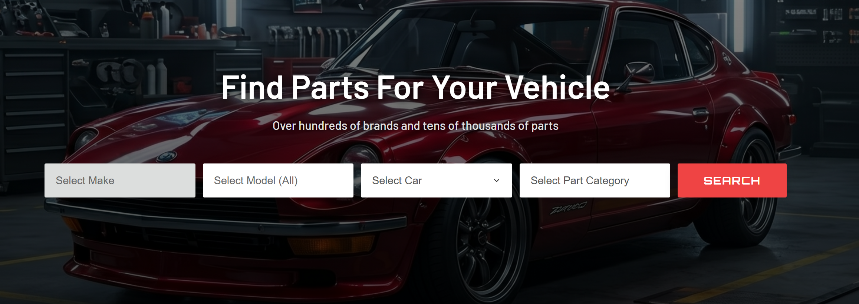

- Use more of engine, transmission, axle and some fasting moving items like oil filter, cabin filter, spark plug etc,
We don’t offer accessories


- Removes accessories in all pages
Include KIA also everywhere

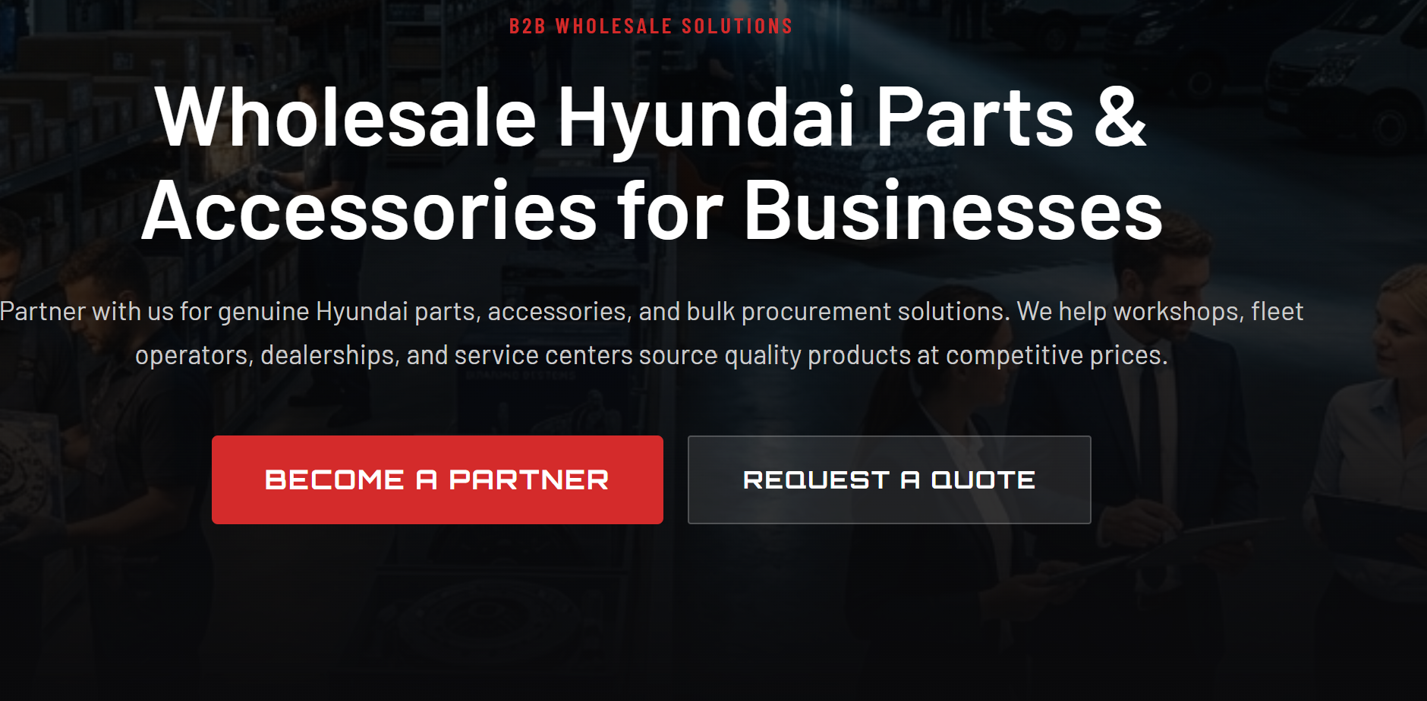

- Tech driven services- just elaborate more on software service
[ This application is yet to be done – I am looking for partner which implement my logic]

